ECOMMERCE MARKETPLACE BUILDER

**API TESTING VIA THUNDER**

**https://github.com/developer-hammad-rehman/template1/blob/main/README.md**

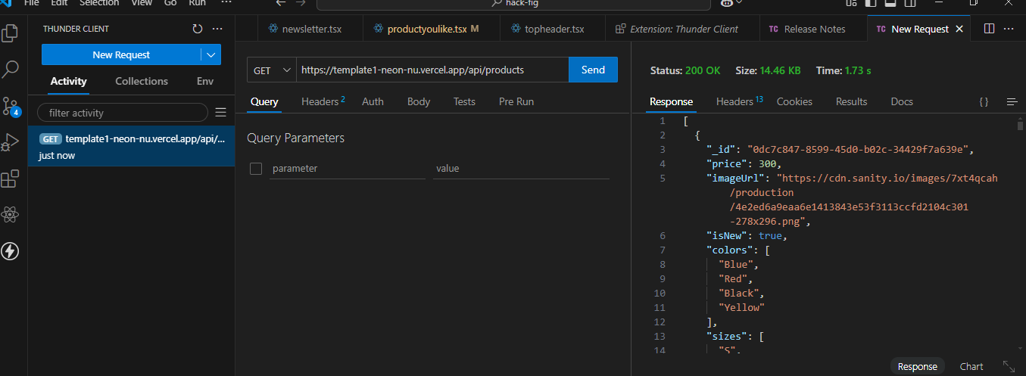

1. **PRODUCT LISTING = PASSED**
2. **TEST API ERROR HANDLIN = PASSED**
3. **CHECK CART FUNCTIONALITY = PASSED**
4. **RESPONSIVE = PASSED**

**PERFORMANCE OPTIMIZATION**

**Desktop performance:**

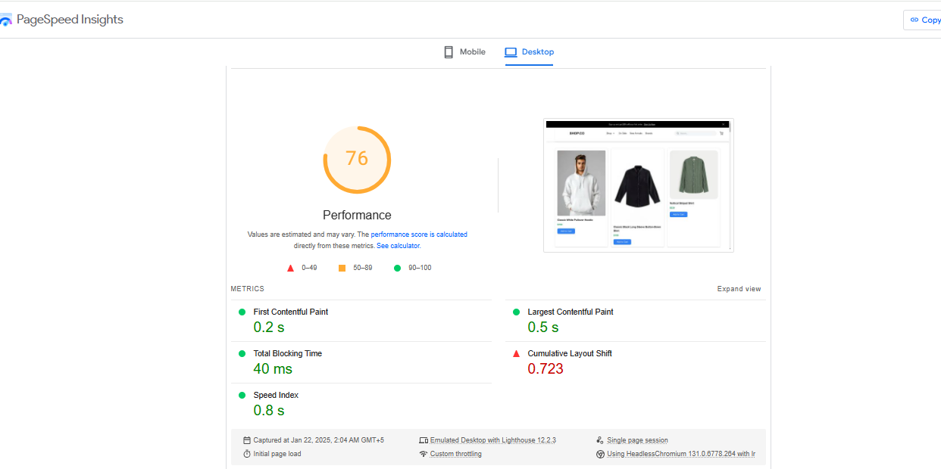

**Mobile performance:**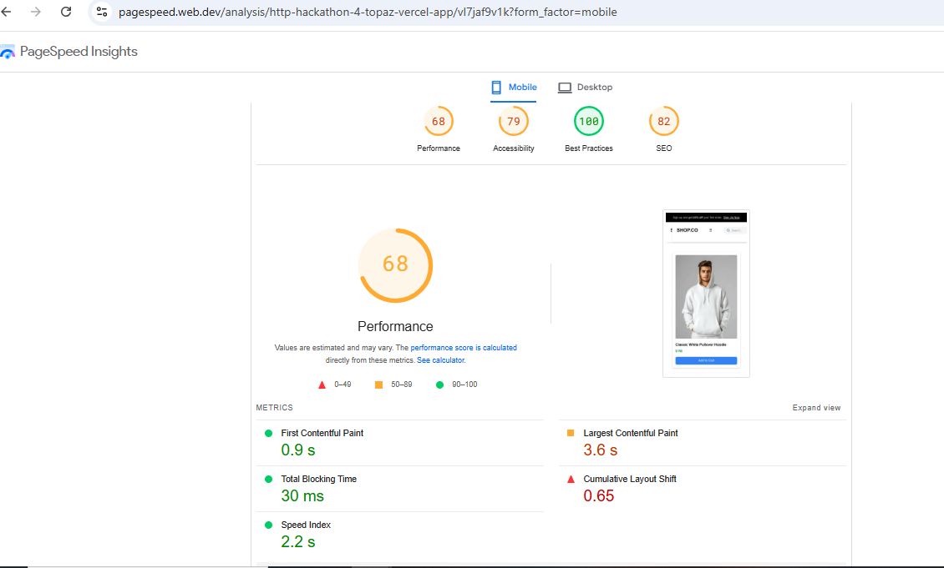

**Developer resources:**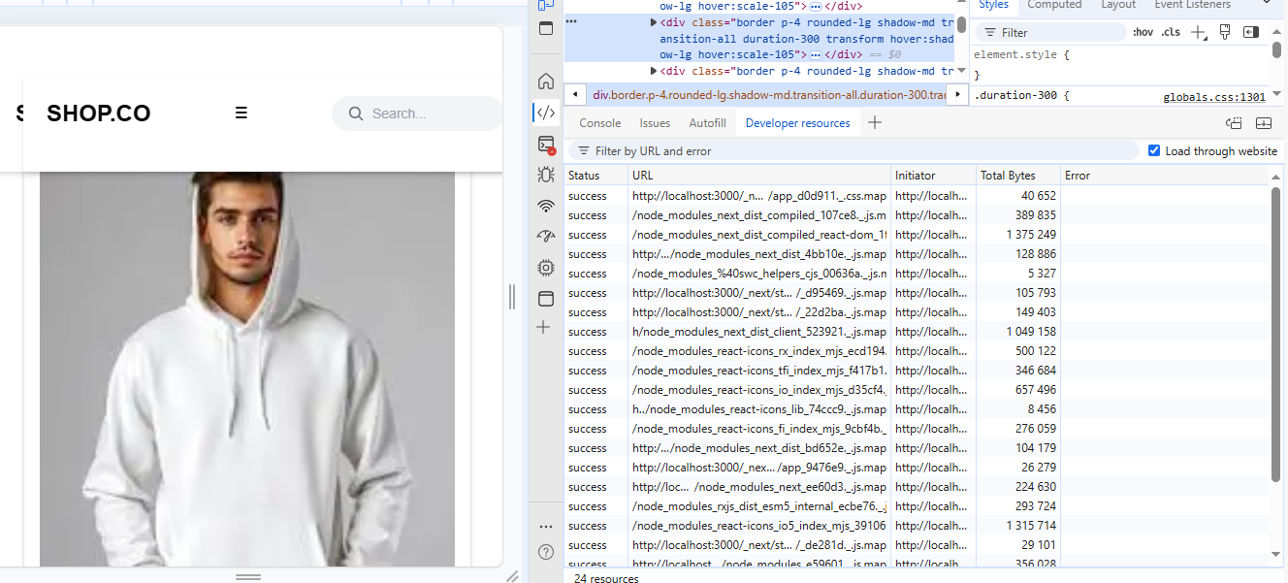

**Performance monitor:**

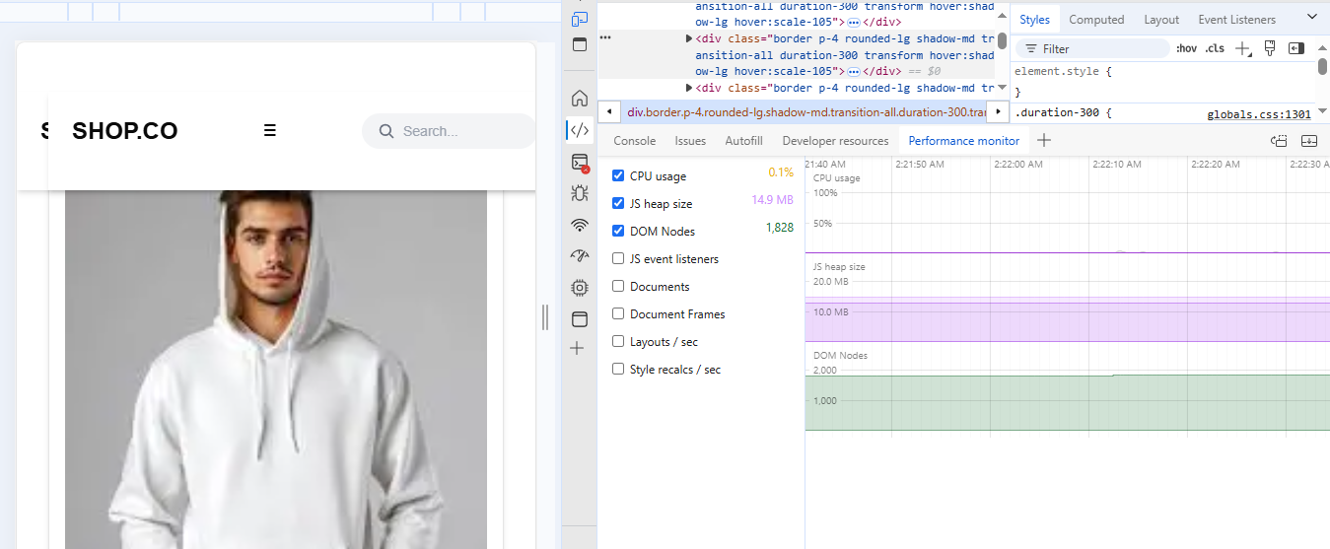

**Security overview:**

